D | d | d | 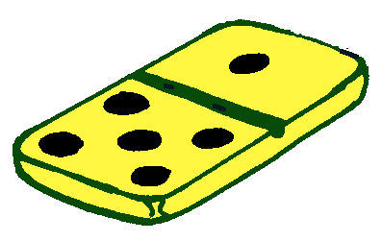
un domino

